**Inheritance**

In C#, inheritance allows us to create a new class from an existing class. It is a key feature of Object-Oriented Programming (OOP).

The class from which a new class is created is known as the base class (parent or superclass). And, the new class is called derived class (child or subclass)

The derived class inherits the fields and methods of the base class. This helps with the code reusability in C#.

**How to perform inheritance in C#?**

In C#, we use the : symbol to perform inheritance. For example,

class Animal {

// fields and methods

}

// Dog inherits from Animal

class Dog : Animal {

// fields and methods of Animal

// fields and methods of Dog

}

Here, we are inheriting the derived class Dog from the base class Animal. The Dog class can now access the fields and methods of Animal class.

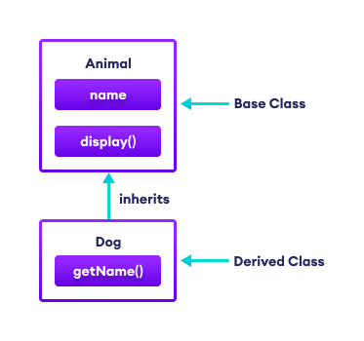C# Inheritance

**Example: C# Inheritance**

using System;

namespace Inheritance {

// base class

class Animal {

public string name;

public void display() {

Console.WriteLine("I am an animal");

}

}

// derived class of Animal

class Dog : Animal {

public void getName() {

Console.WriteLine("My name is " + name);

}

}

class Program {

static void Main(string[] args) {

// object of derived class

Dog labrador = new Dog();

// access field and method of base class

labrador.name = "Rohu";

labrador.display();

// access method from own class

labrador.getName();

Console.ReadLine();

}

}

}

**Output**

I am an animal

My name is Rohu

In the above example, we have derived a subclass Dog from the superclass Animal. Notice the statements,

labrador.name = "Rohu";

labrador.getName();

Here, we are using labrador (object of Dog) to access the name and display() of the Animal class. This is possible because the derived class inherits all fields and methods of the base class.

Also, we have accessed the name field inside the method of the Dog class.

**is-a relationship**

In C#, inheritance is an is-a relationship. We use inheritance only if there is an is-a relationship between two classes. For example,

* **Dog** is an **Animal**
* **Apple** is a **Fruit**
* **Car** is a **Vehicle**

We can derive **Dog** from **Animal** class. Similarly, **Apple** from **Fruit** class and **Car** from **Vehicle** class.

**protected Members in C# Inheritance**

When we declare a field or method as protected, it can only be accessed from the same class and its derived classes.

**Example: protected Members in Inheritance**

using System;

namespace Inheritance {

// base class

class Animal {

protected void eat() {

Console.WriteLine("I can eat");

}

}

// derived class of Animal

class Dog : Animal {

static void Main(string[] args) {

Dog labrador = new Dog();

// access protected method from base class

labrador.eat();

Console.ReadLine();

}

}

}

**Output**

I can eat

In the above example, we have created a class named Animal. The class includes a protected method eat().

We have derived the Dog class from the Animal class. Notice the statement,

labrador.eat();

Since the protected method can be accessed from derived classes, we are able to access the eat() method from the Dog class.

**Types of inheritance**

There are the following types of inheritance:

**1. Single Inheritance**

In single inheritance, a single derived class inherits from a single base class.

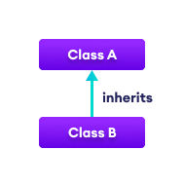C# Single Inheritance

**2. Multilevel Inheritance**

In multilevel inheritance, a derived class inherits from a base and then the same derived class acts as a base class for another class.

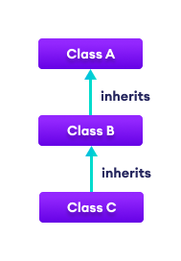C# Multilevel Inheritance

**3. Hierarchical Inheritance**

In hierarchical inheritance, multiple derived classes inherit from a single base class.

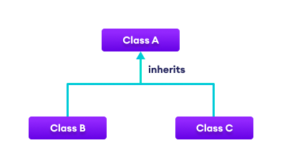C# Hierarchical Inheritance

**4. Multiple Inheritance**

In multiple inheritance, a single derived class inherits from multiple base classes. **C# doesn't support multiple inheritance.** However, we can achieve multiple inheritance through interfaces.

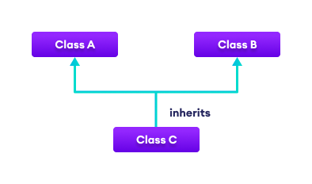Multiple Inheritance

**5. Hybrid Inheritance**

Hybrid inheritance is a combination of two or more types of inheritance. The combination of multilevel and hierarchical inheritance is an example of Hybrid inheritance.

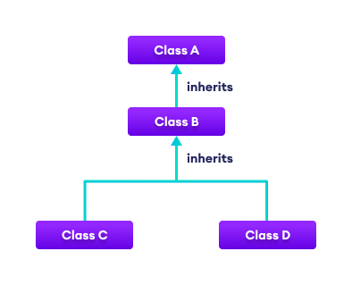C# Hybrid Inheritance

**Method Overriding in C# Inheritance**

If the same method is present in both the base class and the derived class, the method in the derived class overrides the method in the base class. This is called method overriding in C#. For example,

using System;

namespace Inheritance {

// base class

class Animal {

public virtual void eat() {

Console.WriteLine("I eat food");

}

}

// derived class of Animal

class Dog : Animal {

// overriding method from Animal

public override void eat() {

Console.WriteLine("I eat Dog food");

}

}

class Program {

static void Main(string[] args) {

// object of derived class

Dog labrador = new Dog();

// accesses overridden method

labrador.eat();

}

}

}

**Output**

I eat Dog food

In the above example, the eat() method is present in both the base class and derived class.

When we call eat() using the Dog object labrador,

labrador.eat();

the method inside Dog is called. This is because the method inside Dog overrides the same method inside Animal.

Notice, we have used virtual and override with methods of the base class and derived class respectively. Here,

* virtual - allows the method to be overridden by the derived class
* override - indicates the method is overriding the method from the base class

**base Keyword in C# Inheritance**

In the previous example, we saw that the method in the derived class overrides the method in the base class.

**However, what if we want to call the method of the base class as well?**

In that case, we use the base keyword to call the method of the base class from the derived class.

**Example: base keyword in C# inheritance**

using System;

namespace Inheritance {

// base class

class Animal {

public virtual void eat() {

Console.WriteLine("Animals eat food.");

}

}

// derived class of Animal

class Dog : Animal {

// overriding method from Animal

public override void eat() {

// call method from Animal class

base.eat();

Console.WriteLine("Dogs eat Dog food.");

}

}

class Program {

static void Main(string[] args) {

Dog labrador = new Dog();

labrador.eat();

}

}

}

**Output**

Animals eat food.

Dogs eat Dog food.

In the above example, the eat() method is present in both the base class Animal and the derived class Dog. Notice the statement,

base.eat();

Here, we have used the base keyword to access the method of Animal class from the Dog class.

**Importance of Inheritance in C#**

To understand the importance of Inheritance, let's consider a situation.

Suppose we are working with regular polygons such as squares, rectangles, and so on. And, we have to find the perimeter of these polygons based on the input.

**1.** Since the formula to calculate perimeter is common for all regular polygons, we can create a RegularPolygon class and a method calculatePerimeter() to calculate perimeter.

class RegularPolygon {

calculatePerimeter() {

// code to compute perimeter

}

}

**2.** And inherit Square and Rectangle classes from the RegularPolygon class. Each of these classes will have properties to store the length and number of sides because they are different for all polygons.

class Square : RegularPolygon {

int length = 0;

int sides = 0;

}

We pass the value of the length and sides to calculateperimeter() to compute the perimeter.

This is how inheritance makes our code reusable and more intuitive.

**Example: Importance of Inheritance**

using System;

namespace Inheritance {

class RegularPolygon {

public void calculatePerimeter(int length, int sides) {

int result = length * sides;

Console.WriteLine("Perimeter: " + result);

}

}

class Square : RegularPolygon {

public int length = 200;

public int sides = 4;

public void calculateArea() {

int area = length * length;

Console.WriteLine("Area of Square: " + area);

}

}

class Rectangle : RegularPolygon {

public int length = 100;

public int breadth = 200;

public int sides = 4;

public void calculateArea() {

int area = length * breadth;

Console.WriteLine("Area of Rectangle: " + area);

}

}

class Program {

static void Main(string[] args) {

Square s1 = new Square();

s1.calculateArea();

s1.calculatePerimeter(s1.length, s1.sides);

Rectangle t1 = new Rectangle();

t1.calculateArea();

t1.calculatePerimeter(t1.length, t1.sides);

}

}

}

**Output**

Area of Square: 40000

Perimeter: 800

Area of Rectangle: 20000

Perimeter: 400

In the above example, we have created a RegularPolygon class that has a method to calculate the perimeter of the regular polygon.

Here, the Square and Rectangle inherit from RegularPolygon.

The formula to calculate the perimeter is common for all, so we have reused the calculatePerimeter() method of the base class.

And since the formula to calculate the area is different for different shapes, we have created a separate method inside the derived class to calculate the area.